**Setting User Frames Using Automatic Grid Frame Set**

Make sure the camera has been focused, and aperture has been set (see other document)

**Jackpot Frame:**

1. Run the “JR_CALIJACKPOT” TP program. This will move the robot EOAT over the jackpot conveyor.
2. With the robot and grid in position, you can run the Automatic Grid Frame Set function on the robot teach pendent.
   1. Menu
   2. IRVision
   3. Vision Utilities
   4. Automatic Grid Frame Set
   5. Detail (F3)
   6. Arrow down the Start Position, and press Record (F4)
   7. Enter the values shown below for items 1-12

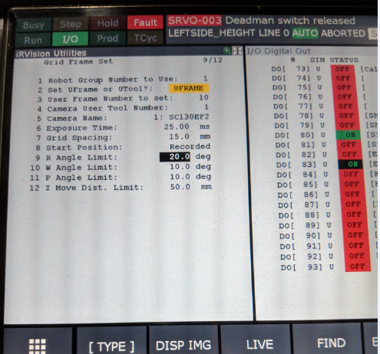

1. Once the starting position has been recorded, and all values set, you can execute the grid frame set function. CAUTION, Robot is going to move once you start!
   1. Make sure Start Position is not highlighted.
   2. While holding the enable switch and shift, press execute.
   3. Once complete, the user frame will be taught for the jackpot Conveyor.